# User

## Introduction

It is possible that you use the BNWAS as a standalone version, but it can also be used in conjunction with the Unimacs bridge. It even can be used with other bridge systems, as long as these systems give the standard EVE-messages.

In this manual we will attend to both ways in the same explanation because the mere differences are just on interface basis and not system-wise.

So when we discuss the interface of the BNWAS system, it can be the interface on the standalone BNWAS or on the integrated BNWAS. It can be the interface on the bridge-panel, but also the interface on the panel in the captain’s cabin. The manual is just the integral explanation of the Imtech BNWAS.

## The HMI overview

The HMI consists of a main screen that holds all the functionality for the BNWAS and a setup-screen that can be used to set up the necessary settings. In the following figures we will explain the functionality and functions on the HMI.

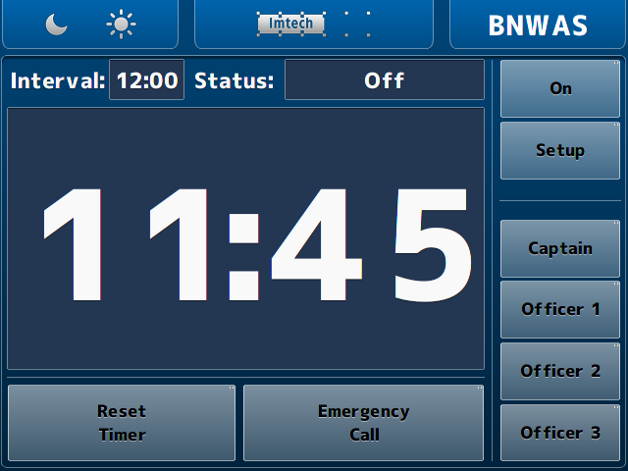

Figure 3‑1: Main BNWAS HMI

## The HMI explained

The functions of the HMI are described in the following figures. These are mostly self-explanatory. Where not really clear, an additional explanation will be given.

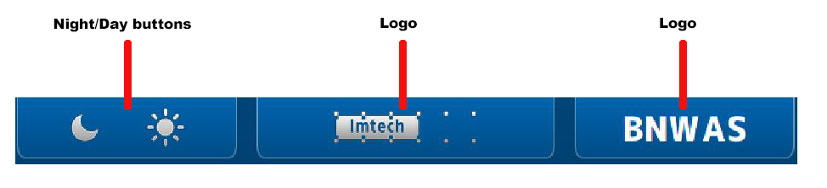

Figure 3‑2: HMI top bar

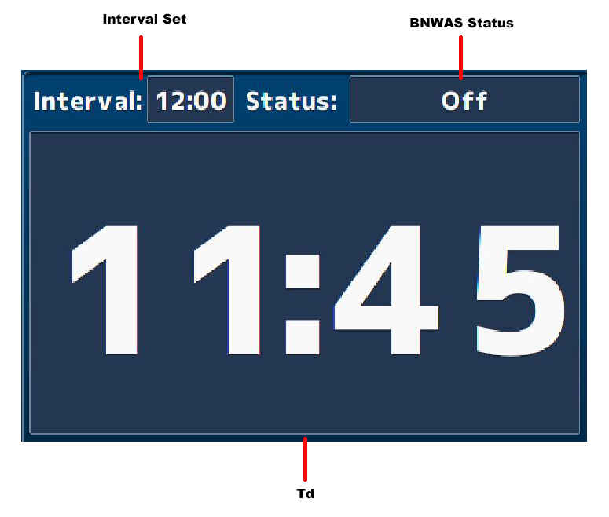

Figure 3‑3: HMI main screen

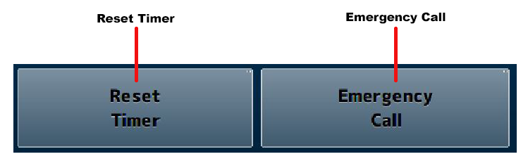

Figure 3‑4: HMI bottom bar

*: The reset timer and emergency call buttons are only available when the panel is placed on the bridge. Any other location will show these buttons, but they will not be operational.*

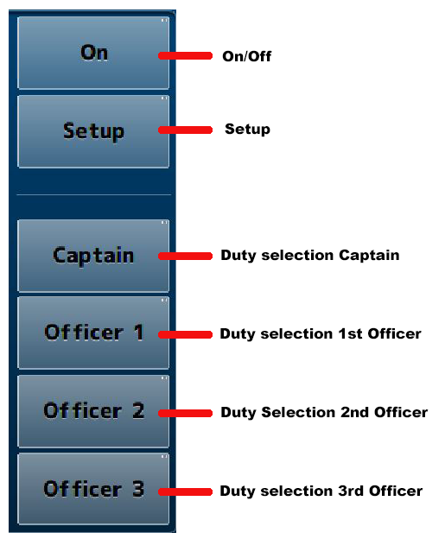

Figure 3‑5: HMI Panel

*: When you operate the “on/off” or “setup” button a keypad will appear where you have to type a “password.” (See* Figure 3‑7*).*

## The setup page

By clicking on the setup-button a new screen will appear. This is the setup screen. It looks quite the same as the main window as it has only a few settings in the main panel (see Figure 3‑8).

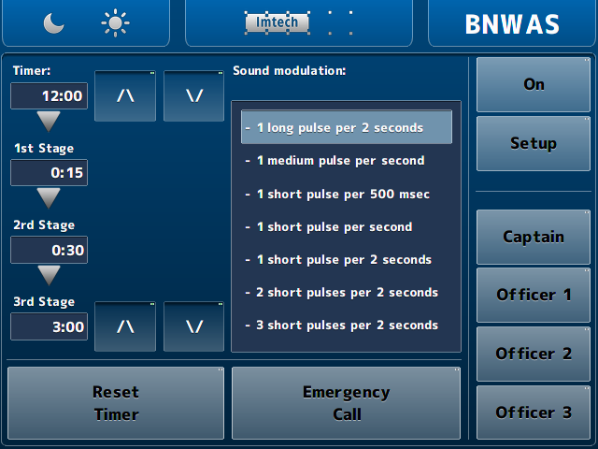

Figure 3‑6: Setup screen

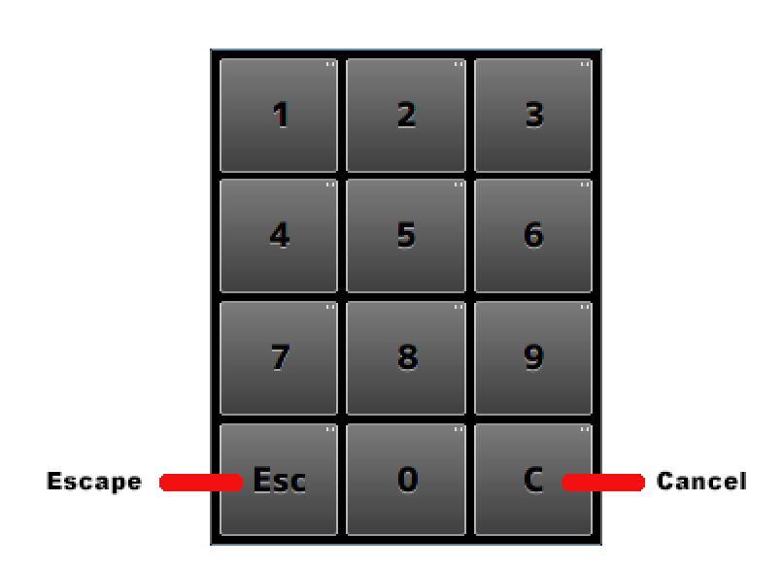

Figure 3‑7: Keypad

The functions, with their respective explanation, are shown in the following figure.

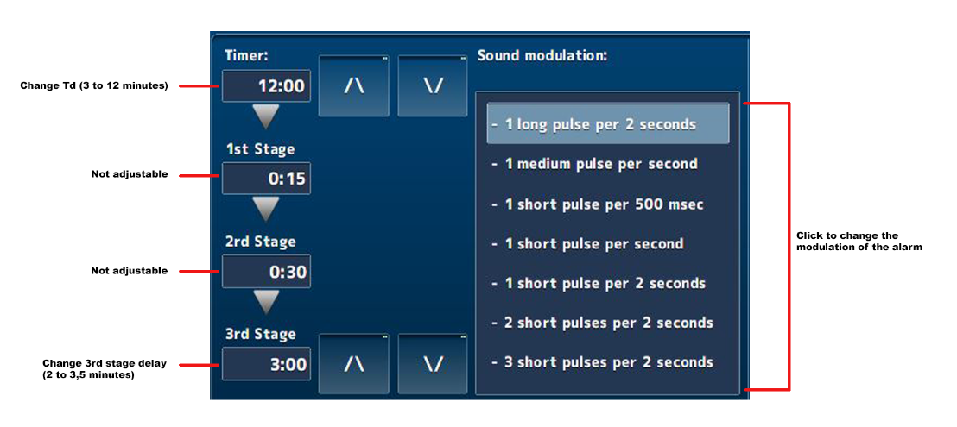

Figure 3‑8: Setup main screen

*: With the arrow-buttons in the setup page you can increase or decrease the Td and/or 3rd stage delay time.*

## The different statuses

Here we show the different states of the BNWAS HMI.

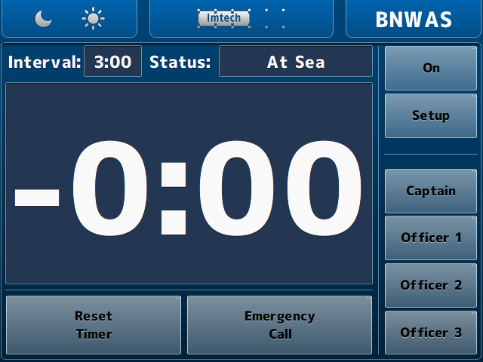

Figure 3‑9: At Sea status

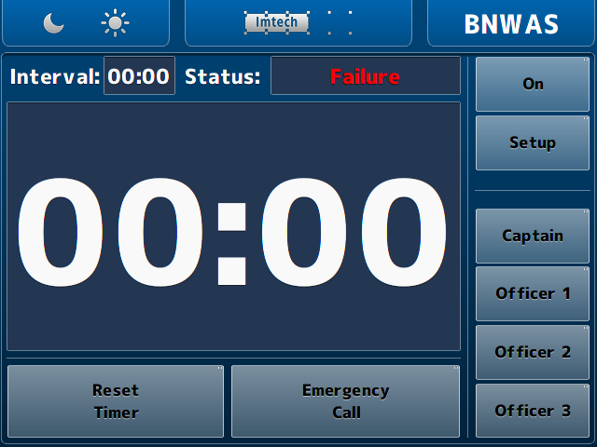

Figure 3‑10: Failure status

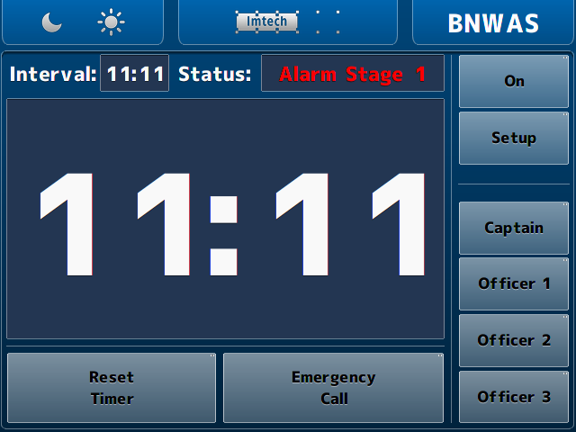

Figure 3‑11: Alarm Stage 1 status

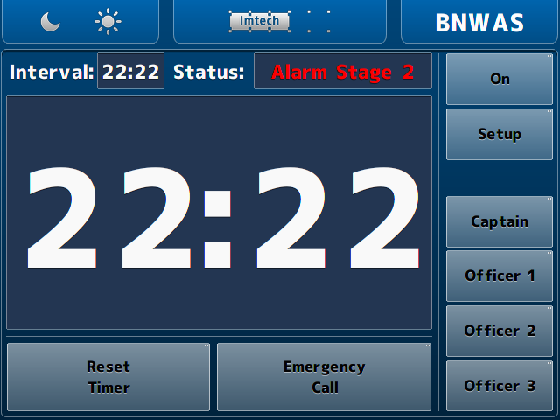

Figure 3‑12: Alarm Stage 2 status

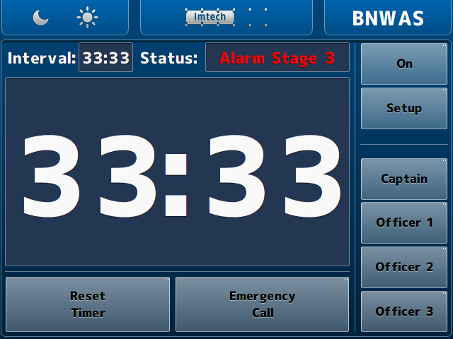

Figure 3‑13: Alarm Stage 3 status